***HIGLEY KNIGHTS BASEBALL YARD SIGNS***

Proudly display your custom yard sign during baseball season!

2x2 4mm Corrugated Plastic with stake - ***$20.00***

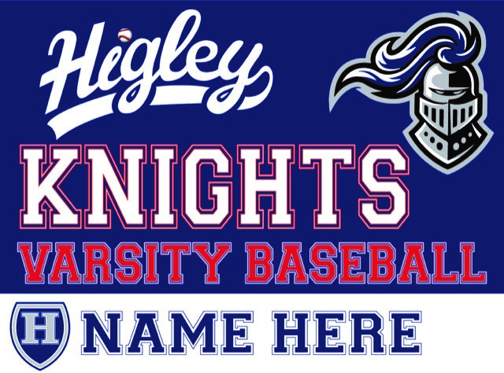

(Sample - Actual sign will not include ‘varsity’ and red will be replaced with carolina blue)

Payment and order form due by **February 20, 2020**

Make check payable to Higley High School Baseball Booster Club

**-----------------------------------------------------------------------------------------------**

Parent Name(s) ­­­­­­­­­­­­­­­­­­ __________________________________________

Email Address __________________________________________

Player Name(s) __________________________________________

_______# sign(s) @$20.00 $_________

TOTAL AMOUNT DUE $_________

***Questions?***

Trisha Leija (615-225-7144) or email [HHSBBINFO@YAHOO.COM](mailto:HHSBBINFO@YAHOO.COM)